UNIT V

Technical challenges, Business model challenges, Scandals and Public perception,Government Regulations, Uses of Block chain in E-Governance, Land Registration, Medical Information Systems

**Technical challenges:**

* [Blockchain technology has demonstrated tremendous potential](https://cointelegraph.com/bitcoin-for-beginners/how-blockchain-technology-works-guide-for-beginners) when it comes to streamlining conventional validation processes that require scalability and transparency.

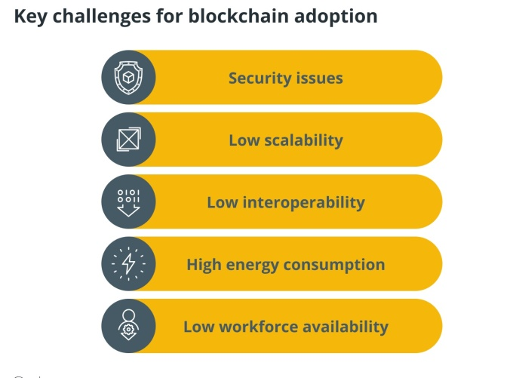.

**Security issues**

Organizations in all industry sectors will face a complicated and potentially contentious array of difficulties, as well as new dependencies, as the blockchain ecosystem matures and additional use-cases arise.

### 51% attacks

* Decentralized blockchains are more susceptible to 51% attacks than centralized ones.
* This has caused a few problems for crypto enthusiasts who prefer to keep their assets on decentralized chains.
* Delving a bit into the details of how 51% attacks work, they exploit an inherent loophole in decentralized systems that allows users to control a chain by wielding over 51% of the processing power.
* This usually happens on networks [utilizing the proof-of-work (PoW) standard](https://cointelegraph.com/blockchain-for-beginners/proof-of-stake-vs-proof-of-work:-differences-explained).
* [Permissionless blockchain systems](https://cointelegraph.com/blockchain-for-beginners/permissioned-blockchain-vs-permissionless-blockchain-key-differences) with low hash rates are particularly prone to these types of attacks. Successful 51% attacks allow hackers to reverse transactions, invalidate new transactions and modify new blocks.
* Blockchain networks that have suffered 51% attacks in recent years include Bitcoin Cash ABC (BCHA), Bitcoin Cash ,[and Ethereum Classic](https://cointelegraph.com/news/ethereum-classic-51-attack-the-reality-of-proof-of-work).

### Flash loan attacks

* The other security problem that blockchain networks face is flash loan attacks.
* These types of attacks are usually leveraged against smart contract DeFi ecosystems because[they offer non-collateralized loans](https://cointelegraph.com/explained/what-are-flash-loans-in-defi).
* Most networks also have lax Know Your Customer (KYC) requirements.
* As such, attackers can make use of arbitrage loopholes to manipulate token value and withdraw profits to other networks, effectively laundering the money.

### Coding loopholes

* Besides hack attacks, blockchain systems are also susceptible to coding loopholes.
* Centralized blockchains are usually more vulnerable as all hackers have to do is undermine specific points of failure. I
* n many instances, entities holding the blockchain keys ([such as private keys](https://cointelegraph.com/tags/private-keys)) are targeted.
* Gaining access to the blockchain keys allows hackers to transfer assets from wallets that are native to the system.

### Centralization of information

* Another security problem that affects blockchain is the centralization of information
* For instance, in November 2020, users on the Compound DeFi protocol lost a cumulative $103 million due to a DAI (the Compound protocol’s native currency) price discrepancy.
* The platform had pulled market price data from Coinbase Pro that was incorrect. The mistake caused prices to jump by 30%. As a result, short sellers with highly leveraged

## Low scalability and interoperability challenges in blockchain technology

* Blockchain technology has evolved over the years to become more scalable as use-cases increase
* scalability issues are plaguing both the Bitcoin and the Ethereum networks.
* As things stand, the Ethereum network is the more popular among blockchain developers.
* In August 2021, Ethereum developers[implemented the London hard fork](https://cointelegraph.com/news/ethereum-london-hard-fork-goes-live) to kickstart the transition from a proof-of-work (PoW) protocol to proof-of-stake (PoS). It helped lower network usage, which had reached alarming levels. In the preceding months, the Ethereum network was running at approximately 98% capacity, a situation that threatened to stall the blockchain.
* [The Ethereum 2.0 upgrade](https://cointelegraph.com/ethereum-for-beginners/ethereum-upgrades-a-beginners-guide-to-eth-2-0) is set to improve scalability by increasing the number of transactions handled per second.
* This will be done through a technique known as sharding. Sharding will increase processing rates from the current optimal speeds of approximately 30 transactions per second (TPS) to over 100,000 TPS by spreading data loads across the chain.
* slow network speeds and high gas fees have forced some projects to shift to more efficient networks such as [the Binance Smart Chain (BSC)](https://cointelegraph.com/blockchain-for-beginners/bsc-network-beginners-guide-to-the-binance-smart-chain-blockchain).
* The BSC network has a higher transaction throughput and lower gas fees. The BSC network also has Ethereum Virtual Machine (EVM) support. This means that it can handle applications built for the Ethereum chain.

## Energy consumption blockchain challenges

* The Bitcoin and Ethereum blockchain systems are among the most popular. They are, however, energy-intensive proof-of-work systems that depend on mining to validate blocks and transactions.
* BTC mining, alone, is estimated to use approximately [100 terawatt-hours of electricity](https://cointelegraph.com/bitcoin-for-beginners/how-to-mine-bitcoin-everything-you-need-to-know) every year. This is more than the amount of energy used in countries such as Finland.
* Its carbon footprint is also significant and is estimated to be roughly 97 metric tons of carbon dioxide produced every year.

## Low workforce availability

* The blockchain industry has experienced an [explosion of nonfungible tokens](https://cointelegraph.com/nonfungible-tokens-for-beginners/what-are-nfts-and-why-are-they-revolutionizing-the-art-world) and DeFi projects over the past year causing problems in the labor market.
* According to the latest statistics, demand for blockchain talent[has increased by over 300%](https://cointelegraph.com/news/crypto-job-posts-on-linkedin-rocketed-395-in-2021)as both established firms and startups scramble for top-tier talent.
* Top blue-chip firms such as Google, Amazon, Goldman Sachs, the Bank of New York Mellon Corporation and DBS Group are already hiring blockchain specialists by the hundreds, and this is creating a labor shortage.
* A quick look at LinkedIn’s job post results shows that there are currently over 6,000 listed blockchain and cryptocurrency jobs.
* This isn’t even scratching the surface because job sites such as Indeed and ZipRecruiter have over 15,000 listed blockchain jobs each.

**Business model challenges**

* Blockchain has disrupted many industries and transformed how businesses innovate, function, and engage with customers
* Blockchain-based business models have helped companies to change their strategies and discover new ways to survive in a digital world.
* Blockchain-based business models are distinguishable from traditional businesses by adopting the three critical features of DLT, which are:

**Decentralization**:

* Data and the records of transactions are stored inside a blockchain and are shared by all networks so that no individual entity has a monopoly on the records.

**Immutability**:

* No one can tamper with data stored in the Blockchain, thanks to cryptography promoting the highest level of cyber-security.

**Transparency**:

* The ability of the Blockchain to hide a user’s identity via the complex science of cryptography, so a public address only represents them, is at a level that has never been seen before. 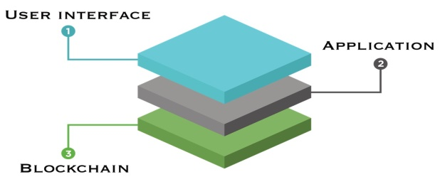
* Blockchain combines cryptographic algorithms, asymmetric-key algorithms, and hash functions.
* The technology consists of several layers
* hardware infrastructure layer
* data layer
* network layer
* consensus layer
* application layer.

**#1. Layer 0**

* Layer 0 refers to the initial stage of the Blockchain, which enables numerous functions like [Bitcoin](https://geekflare.com/finance/bitcoin-mining-for-dummies), Ethereum, and others to operate.
* It’s Layer 0 that provides the Blockchain’s underlying infrastructure as well as cross-chain interoperability communication within the different layers.

### #2. Layer 1

* Blockchain’s Layer 1 is a progression from layer 0, where the network’s functionality is maintained. Also called the implementation layer, limitations such as scalability are experienced at this level, while any changes happening on any new protocol on layer 0 directly affect layer 1.
* Bitcoin, Ethereum, Ripple, [Cardano](https://geekflare.com/cardano-nft/), and several other cryptocurrencies are examples of layer 1 blockchains.

### #3. Layer 2

* Layer 2 refers to the scaling solution by specific platforms interacting with third parties to remove limitations and challenges experienced at layer 1.
* Layer 2 solutions are currently among the most popular solutions aimed at solving issues arising from the proof-of-work (PoW) consensus mechanism.

### #4. Layer 3

* Layer 3 of the Blockchain is also known as the application layer, and it’s what hosts [Decentralized Applications](https://geekflare.com/finance/top-dapps) (DApps) and other protocols that support different apps.
* The blockchain protocol at layer 3 can be further split into two sub-layers: application and execution.

**The Traditional Business Model**

* The traditional business model is centralized and comprises owners or shareholders, a company, its employees, and consumers.
* In this model, the business offers goods or services through which it earns profits.
* Once they have created their products, they expect consumers to buy their products or service at a specific rate.

## The Blockchain Business Model

* blockchain business model comprises the three main characteristics of blockchain technology: decentralization, immutability, and transparency.
* The nature of business is mainly through peer-to-peer transactions within a reliable and trustworthy network.
* The concept of decentralization completely changes the way businesses function.
* Factors like how profits are made and the flow of transactions and entities are designed differently to help enhance how the businesses and the end-user benefit.

**Difference Between Traditional Business Models and Blockchain Business Models**

* **Centralization vs Decentralization-**
  + Most of the traditional business models are dependent on a centralized authority to manage business transactions.
  + But in a Blockchain business model, a decentralized network of computers is utilized to enhance the security of transactions and it also keeps a proper record of the information.
* **Intermediaries vs Direct Transactions-**
  + In traditional business models businesses often have to rely on intermediaries to facilitate transactions but in Blockchain business models businesses can enjoy direct transactions.
* **Transparency-**
  + In Blockchain business models the highest level of transparency can be achieved, as the ledger is open and accessible for all the parties.
  + While on the other hand in traditional business models trust is ensured by intermediaries like banks and lawyers.
* **Data Management-**
  + Traditional business models rely on centralized data storage which makes the data vulnerable to hacking and tampering.
  + But in Blockchain business models businesses use decentralized data storages which are more secure and tamper-proof.

## Different Types of Blockchain Business Models

1. **P2P Blockchain Business Model-**
   * P2P or peer-to-peer, Blockchain business model is referred to businesses that utilize Blockchain technology to facilitate direct transactions with individuals.
   * This type of Blockchain business model makes it possible to eliminate the third-parties or intermediaries and allow users to securely and directly transact with each other.
   * An example of a P2P Blockchain business model is the cryptocurrency exchanges like Uniswap.
   * It is a cryptocurrency exchange platform that allows users to buy, sell, and trade cryptocurrencies directly with each other.
   * The current market capitalization of Uniswap is [$5.37 billion](https://www.coinbase.com/price/uniswap#:~:text=What%20is%20the%20market%20cap,highly%20valued%20by%20the%20market.).
2. **Blockchain as a Service (BaaS) Business Model-**
   * BaaS or Blockchain as a Service, is a business model that allows businesses to build and deploy their Blockchain-based solutions using cloud-based infrastructure and tools.
   * This model allows businesses to incorporate innovative Blockchain technology into their operations without having to develop their solutions from ground zero.
   * In the BaaS business model, businesses usually charge users a fee to access their services.
   * An example of a Blockchain as a Service (BaaS) provider that offers blockchain solutions built on popular blockchain platforms like Ethereum is Microsoft Azure.
   * Microsoft Azure provides a cloud-based platform for businesses to build, deploy, and manage their blockchain applications and solutions.
3. **Token Economy- Utility Token Business Model-**
   * In this type of Blockchain business model a business leverages the creation and use of tokens to drive its operations. U
   * tility tokens are a specific type of cryptocurrency that can be used to access a particular product or service within a particular platform.
   * One of the most prominent examples of a Utility token business model is MakerDAO, a Decentralized Autonomous Organization (DAO).
4. **Blockchain-Based Software Products-**
   * “Blockchain-based Software Product” Blockchain business model focuses on building software products that utilize the power of Blockchain technology to solve particular problems.
5. **Development Platforms-**
   * In this Blockchain business model a business offers the tools and infrastructure for other companies and developers to develop and deploy their Blockchain solutions.
   * Development platforms offer a comprehensive suite of tools like APIs and SDKs to simplify Blockchain integration into the operations of other businesses.
   * Hyperledger is one of the best examples of the “Development Platforms” Blockchain business model. This platform offers tools, frameworks, and even guidelines for Blockchain development.

#### Advantages of Using Blockchain Business Models

* **Trustless Systems-**
  + With blockchain, parties can engage in transactions without the need for a centralized authority, establishing trust through code. This results in increased security and reduced risk of fraud or manipulation.
* **Automation-**
  + Smart contracts, self-executing agreements, are made possible through blockchain, streamlining and simplifying contractual relationships. This eliminates the need for manual contract enforcement and reduces the potential for human error.
* **Cost-Effective-**
  + By bypassing intermediaries, blockchain reduces fees and verification costs associated with intermediation. This results in lower costs for users and businesses and increased efficiency.
* **Optimized Privacy-**
  + Transactions and personal information are kept confidential, enhancing privacy for users. This protects sensitive information and ensures that user data is not misused or sold.
* **Data Empowerment-**
  + Users control and own their data, rather than relying on centralized entities. This gives users more control over their information and reduces the risk of data breaches and theft.
* **Decentralized Identity-**
  + Blockchain enables the creation of secure, decentralized digital identities. This offers a more secure and efficient way to store and manage personal information compared to traditional centralized systems.
* **Scalability-**
  + With the potential to handle global systems, blockchain technology provides a scalable solution for new and innovative use cases. This opens up opportunities for businesses and organizations to create new products and services that can benefit from the benefits of blockchain technology.

#### Challenges Associated with Blockchain Business Models

* **Regulations-**

The biggest challenge in the Blockchain business model is the regulations. As the technology is still emerging and continuously evolving there is a lack of clear regulatory guidance making it difficult for businesses to know how to comply with the law.

* **Adoption-**

Although Blockchain technology brings an array of benefits along with it, there is still a lack of knowledge and awareness about this innovative technology and its potential. So, it can give businesses a hard time gaining traction and developing a user base.

* **Interoperability-**

With many different blockchain platforms and protocols in use, interoperability between different systems can be a challenge, making it difficult for them to interact with each other and exchange data seamlessly.

* **Complexity-**

The technical nature of blockchain technology can make it challenging for businesses to understand and implement, requiring significant technical expertise and resources.

* **Integration-**

Businesses adopting Blockchain business models can find it very difficult to integrate innovative technology into their existing systems and processes. As it requires technical expertise it will be not that easy for businesses to integrate.

**Scandals and Public perception:**

* **Privacy Limitations-**

Pseudonymity is one of the critical features of Blockchain Technology, and when it talks about anonymity, then it means that we know that the transactions or trading is happening from someplace, but there’s no real-world identity attached to the same.

* **Lack of Regulations And Governance** –

The critical feature of Blockchain Technology is that it lacks regulation. It allows peer-to-peer transaction which means there is no intermediary.

* **Cost to set up-**

The cost to setup-the developers might be preaching a lot about Blockchain Technology, but we cannot ignore the fact that to set up the entire system of Blockchain Technology is expensive especially if you wish to set up the whole operation in-house.

* **Huge consumption of energy-**

One of the important areas of concerns while using Blockchain Technology for cryptocurrency exchange is the energy it consumes. Whether it is Bitcoin or Ethereum network, to validate the transactions they follow Proof-Of-Work mechanism which consumes a lot of energy while solving complex mathematical problems.

* **Public Perception-**

The biggest drawback in the way of the success of Blockchain is the perception it holds in the eyes of people. Firstly, people don’t see it be a part of mainstream functioning. Secondly, most of the people believe that this technology will not last long. The feature like the lack of governance, easy access to become a member of public Blockchain and lack of regulation further deteriorates the image of Blockchain in the eyes of people

**Government Regulations**

* The regulations are mostly limited to cryptocurrencies and ICOs. While blockchain is still in its infancy, governments around the world recognize the value of distributed ledger technology.
* Switzerland has been among the pioneers in the blockchain field.
* One of its cities — Zug — hosts several blockchain startups and offers a flexible taxation and solid legislative protection to the companies of the blockchain breed.
* Canada is another example of how regulators can embrace the technology. Recently, the Canadian government allowed to issue an [ETF for blockchain technologies](https://www.coindesk.com/canada-approves-countrys-first-blockchain-etf/), which can now be traded on the Toronto Stock Exchange. Apart from that, the National Research Council (NRC) of Canada utilizes blockchain technology to better track and publish information about grant funding.
* China might see to be harsh “on the current blockchain hype [which] is focusing on fundraising and speculation,” says Hu Danqing, a technology product specialist from Alibaba, in an [interview](https://www.coindesk.com/chinas-state-media-blockchain-needs-regulation-grow/). Still, the country’s officials believe that the blockchain technology can solve real-world problems.
* The United States, the UK, Singapore and Japan do not intend to scare away the blockchain industry professionals, admitting the need for proper blockchain regulation.
* During the hearing in the US on February 6, 2018, the Securities and Exchange Commission (SEC) chairman Jay Clayton and the Commodity Futures Trading Commission (CFTC) chairman Christopher Giancarlo spoke before the Senate Banking Committee on the topic of [virtual currencies](https://www.banking.senate.gov/public/index.cfm/hearings?ID=D8EC44B1-F141-4778-A042-584E0F3B9D39).
* The *[EthNews](https://www.ethnews.com/seven-takeaways-from-the-sec-and-cftcs-testimony-on-virtual-currency" \t "_blank)* summarized the hearing’s with most important statements. For instance, both commissioners agree there is no systematic risk coming from cryptocurrencies, since their market capitalization remains a small part of the global economy.
* The officials also admitted they lacked economists in the blockchain field and that blockchain regulation on the state level is still chaotic. Thus, a solution to the current status quo, as well as blockchain implementation in the government sector, are welcomed. Marco Santori of Cooley once emphasized that [blockchain and cryptocurrency regulation](https://www.forbes.com/sites/laurashin/2017/12/12/how-crypto-and-blockchain-technology-should-be-regulated/" \l "b7533ea67ba9" \t "_blank) depends on the applications of the technology.

**Uses of Block chain in E-Governance:**

**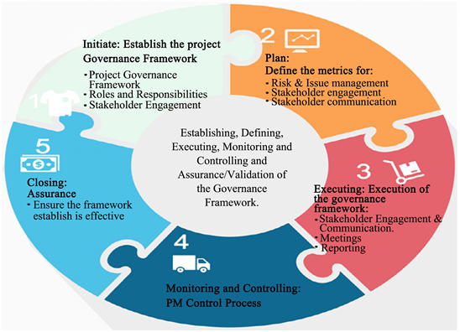**

**Governance model:**

* selecting the right model is key for ensuring the success of the program.
* Defining a compatible governance model aligning the organization’s needs will help to achieve the desired missions required for the program with regards to baseline, cost, time, risk and stakeholder engagement and expectations.

**Accountability and responsibility:**

* assigning roles and responsibilities is very critical to any project or program as everyone will be aware of what is expected from them to look after and deliver.

**Stakeholder Engagement:**

* Stakeholder’s needs and expectations are very important for the program team as their unacceptance of the program deliverables will have a significant impact on the success of the program.

**Stakeholder communication:**

* After the identification of all stakeholders in the program, a clear communication plan needs to be established to depict how and when the deliverables and milestones will be conveyed to the stakeholders throughout the program life cycle.

**Risk and issue management:**

* risks will always be associated with projects and programs, but the main concept of risk is how to deal with them once occurred.
* Risks can be expected at any stage of the program but setting a plan for how to deal with different types of risks at early stages will provide extra resilience to the program team to react accordingly.

**Assurances**:

* this is the blueprint that ensures that all risks are managed effectively and also it ensures setting program performance KPIs.

**Project management control process:**

* This task is vital as it will oversee all program deliverables status and gives the right window to intervene. This task is activated throughout the full program life cycle.

**Challenges of Traditional Governance**

**E-governance**

* Electronic governance is the implementation of ICT in the project or program governance, which will result in better governance through simple process creation and efficient communication with various stakeholders .
* In program management, the uses of e-governance focus on decision-making, management, services, and transactions.

**Decision-making**

* The electronic governance will bring all stakeholders and connect them via online portals, which provides clearer and stronger accessibility to the information.
* As a result, more transparency is created and efficient decision-making will take place among the stakeholders.

**Management**

* Electronic governance helps in managing program and project teams efficiently as the execution will be monitored through various online channels.
* This helps in creating more transparency and efficient governance for large projects.

**Services**

* Conducting services online is one of the main features e-governance provides. Accessibility to the online platforms will result in better delivery of different kinds of services to the stakeholders.

**Transactions**

* The application of the internet eases the transactions between firms and individuals.
* Using online payment channels to perform transactions has helped companies to reduce cost compared to traditional transactions and also it increases the marginal profit due to the high level of exposure.

**Blockchain and E-governance**

* Blockchain brings an innovative and disruptive solution that helps in shifting the focus from a centralized system to distributed system that is efficient and transparent to all participants in the system.

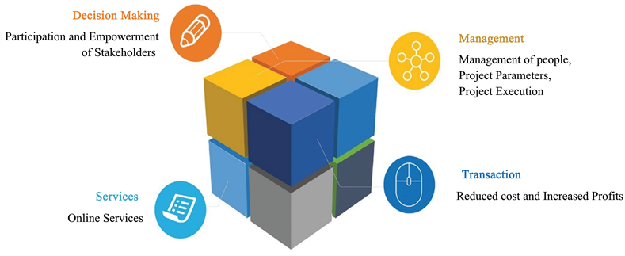

**Data Security**

* Cybersecurity is one of the challenges that governments and corporations face against cyberattacks.
* Blockchain has been designed to encrypt data that is exchanged between parties. Also, it provides an extra layer of security for the data as it facilitates digital certification and signature for each and every transaction.

**Blockchain and Purchase Management**

* Procurement and purchase order management is an essential process in the program management cycle; ensuring the delivery note adherence and invoices are important to ensure that the vendors are getting paid on time.
* In prior years, this process was managed and operated manually, causing a high level of inefficiencies. Usually, due to the inefficiencies, suppliers don’t get paid on time.
* Blockchain technology replaces all the manual processes with distributed digitalized form and enhances the overall process and releases the certified payment on time
* it processes the correct decision-making related to the right products purchased and it creates undisrupted communication channels with all stakeholders involved.

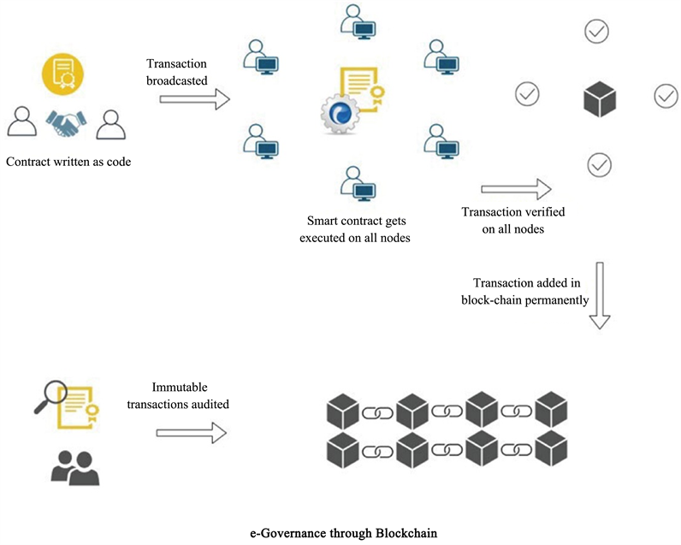

**Uses of Block chain in Land Registration:**

* Land registration is a topic that hardly crosses the mind of most people outside of the real estate sector, except for when they’re involved in a real estate transaction themselves.
* Even then, it’s generally considered one of the mundane administrative matters, a rubber-stamping exercise that’s far less tangibly exciting than collecting the keys to a new home.
* the critical role of land registration in the real estate markets cannot be understated.
* In 2018, the volume of global real estate transactions reached [$1.75 trillion](http://www.cushmanwakefield.com/en/news/2019/03/global-real-estate-investment-volumes-reach-record-high), four percent higher than the previous year.
* Behind each of these transactions is a land registry paper trail that varies vastly in both qualitative and quantitative measures.

# Challenges of the Land Registration Process

* In principle, land registries simply need to maintain records of land and real estate ownership, recording changes of hands as they happen over the years. It sounds like a simple enough task, but it comes with myriad challenges.

# A Failing System

* This scenario is depicted in the UK as a developed country with a relatively robust system of land registration. Around the world, the picture looks very different.
* For example, in 2010, an earthquake devastated large parts of the country of Haiti, leaving [1.5 million people](https://www.reuters.com/article/us-haiti-landrights-quake/in-haitis-city-without-a-government-residents-want-land-titles-taxation-idUSKCN1P60IQ) homeless. The disaster also destroyed [60 years’ worth](http://www.terradaily.com/reports/Haiti_quake_destroyed_or_damaged_60_years_of_archives_999.html) of government archives, including land registrations.
* Even in the absence of such a disaster, land registries in the developing world are often severely lacking. As recently as 2004, only [one percent of land](https://www.irbnet.de/daten/iconda/CIB20132.pdf) in sub-Saharan Africa was under formal government registration.
* A [2018 study](https://www.researchgate.net/publication/326010732_Challenges_to_Land_Registration_in_Kaduna_State_Nigeria) into the challenges of land registration in a state within Nigeria found that only 11 percent of real estate consultant respondents stated that they always registered residential land purchases

**Putting Land Registries on the Blockchain**

* Blockchain provides a potential solution for many of the challenges of land registration. This use case for blockchain extends beyond a pure database, leveraging the opportunity to create a permanent, unbreakable record of ownership for land or real estate.
* The simplest implementation of a blockchain-based land registry could enable the ownership documents to be recorded and assigned to the owner’s user account

**Breathing New Potential into Real Estate Ownership**

* Beyond these features, tokenization and smart contracts unlock vast potential for the ownership of real estate. If the property is represented as a digital token on the blockchain, it can be divided between parties, enabling fractional ownership of a building or piece of land. Such a use-case is absolutely unthinkable with paper-based registries.
* Although not all of these scenarios are yet a reality, and some, such as selling part-ownership may have legal considerations for implementation. However, some countries are already turning to blockchain for land registration, including [Sweden](https://www.coindesk.com/sweden-demos-live-land-registry-transaction-on-a-blockchain) and [Ukraine](https://www.bloomberg.com/news/articles/2017-10-03/ukraine-turns-to-blockchain-to-boost-land-ownership-transparency).
* [Georgia](https://medium.com/bitcoinblase/blockchain-application-land-register-georgia-and-sweden-leading-e7fa9800170c) is another example, where 300,000 land titles have already been registered. The sale process now takes minutes, rather than days, with operational cost reductions of up to 90 percent. With these efficiencies, it’s surely only a matter of time before other governments start to leverage the potential of blockchain for their own national land registries.

**Uses of Block chain Medical Information Systems:**

* Blockchain’s distributed ledger technology facilitates the secure transfer of patient medical records, strengthens healthcare data defenses, manages the medicine supply chain and helps healthcare researchers unlock genetic code.
* With its ability to deflate the current spending bubble, protect [patient data](https://builtin.com/healthcare-technology/patient-data-micromoments-future-healthcare) and improve the overall healthcare experience, using [blockchain](https://builtin.com/blockchain" \t "_blank) in healthcare may help ease the pain.
* The technology is already being used to do everything from securely [encrypting patient data](https://builtin.com/cybersecurity/encryption-mechanisms) to managing the outbreak of harmful diseases.
* Decentralized data logs that are incorruptible and transparent
* Complex codes that protect individuals’ identities and data
* Quick transfers that reduce the window in which data is vulnerable

### 1. AKIRI

[](https://builtin.com/company/akiri)

**Location:** Foster City, California

* [Akiri](https://akiri.com/) operates a network-as-a-service optimized specifically for the healthcare industry, helping protect transportation of patient health data.
* The Akiri system does not store data of any kind. It operates as both a network and a protocol to set policies and configure data layers while verifying the sources and destinations of data in real time.
* Akiri ensures healthcare data remains secure and shareable with only the parties authorized for access at the moment when they need it.

### 2. BURSTIQ

[](https://builtin.com/company/burstiq)

**Location:** Denver, Colorado

* [BurstIQ](https://www.burstiq.com/)’s platform helps healthcare companies safely and securely manage massive amounts of patient data.
* Its blockchain technology enables the safekeeping, sale, sharing or licensing of data while maintaining strict [compliance with HIPAA rules](https://builtin.com/healthcare-technology/hipaa-compliant-email).
* Because BurstIQ’s platform includes complete and up-to-date information about patients’ health and healthcare activity, it could help to root out abuse of opioids or other prescription drugs.

### 3. MEDICALCHAIN

[](https://builtin.com/company/medicalchain)

**Location:** London, England

* [Medicalchain](https://medicalchain.com/en/)’s blockchain maintains the integrity of health records while establishing a single point of truth. Doctors, hospitals and laboratories can all request patient information that has a record of origin and protects the patient’s identity from outside sources.

### 4. GUARDTIME

[](https://builtin.com/company/guardtime)

**Location:** Lausanne, Switzerland

* [Guardtime](https://guardtime.com/) is helping healthcare companies and governments implement blockchain in their [cybersecurity](https://builtin.com/cybersecurity" \t "_blank) methods.
* The company was vital in helping implement blockchain in Estonia’s healthcare systems, and it signed a deal with a private healthcare provider in the United Arab

5. AVANEER HEALTH

[](https://builtin.com/company/avaneer-health)

**Location:** Chicago, Illinois

* [Avaneer](https://avaneerhealth.com/) is a company backed by Aetna, Anthem, Cleveland Clinic and other healthcare leaders that is dedicated to using [blockchain technology](https://builtin.com/blockchain/private-blockchain" \t "_blank) to improve healthcare efficiency.
* Avaneer uses a public ledger to support better claims processing, secure healthcare data exchanges and keep provider directories maintained and up-to-date.

### 6. PROCREDEX

[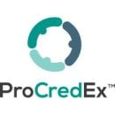](https://builtin.com/company/professional-credentials-exchange)

**Location:** Tampa, Florida

* [ProCredEx](https://procredex.com/) has created a distributed ledger of healthcare credentials data that boosts complex dataset efficiency by rendering the data immutable and permanently traceable.
* It allows data to be curated to meet unique organizational requirements and shared with authorized partners.
* The platform uses proprietary validation engines and restricts memberships to vetted and approved organizations so health systems can rapidly acquire verified credentials and promote patient safety and care quality.

### 7. CORAL HEALTH

[](https://builtin.com/company/coral-health)

**Location:** New York, New York

* [Coral Health](https://www.coralhealth.com/) uses blockchain to accelerate the care process, automate administrative processes and improve health outcomes.
* By inserting patient information into distributed ledger technology, the company connects doctors, scientists, lab technicians and public health authorities quicker than ever.
* Coral Health also implements [smart contracts](https://builtin.com/blockchain/smart-contracts-blockchain) between patients and healthcare professionals to ensure data and treatments are accurate.

### 8. PATIENTORY

[](https://builtin.com/company/patientory)

**Location:** Atlanta, Georgia

* [Patientory](https://patientory.com/)’s end-to-end encryption ensures that patient data is shared safely and efficiently.
* The company’s platform enables patients, healthcare providers and clinicians to access, store and transfer all important information via blockchain.
* Patientory helps the healthcare industry move more quickly by housing all patient information under one roof.

### 9. CHRONICLED

[](https://builtin.com/company/chronicled)

**Location:**San Francisco, California

* [Chronicled](https://chronicled.com/) builds blockchain networks that demonstrate chain-of-custody. The networks help pharma companies make sure their medicines arrive efficiently, and they enable law enforcement to review any suspicious activity — like [drug trafficking](https://builtin.com/blockchain/blockchain-in-government).
* Chronicled also created the [Mediledger Project](https://www.mediledger.com/" \t "_blank), a ledger system dedicated to the safety, privacy and efficiency of medical supply chains.

### 10. EMBLEEMA

[](https://builtin.com/company/embleema)

**Location:** New York, New York

* [Embleema](https://www.embleema.com/) is a virtual trial and regulatory analytics platform designed to fast track drug development. Users are recruited to digitally consent to secure, untampered medical data collection, which is then stored on Embleema’s blockchain and analyzed.
* Embleema’s platform allows patients to assist in speeding up treatment availability and improving safety, all through the company’s Virtual Studies Suite.

### 11. BLOCKPHARMA

[](https://builtin.com/company/blockpharma)

**Location:** Paris, France

* [Blockpharma](https://www.blockpharma.com/) offers a solution for drug traceability and counterfeiting.
* By scanning the supply chain and verifying all points of shipment, the company’s app lets patients know if they are taking falsified medicines With the help of a blockchain-based supply chain management system, Blockpharma says it helps to weed out the 15 percent of all medicines in the world that are fake.

### 12. TIERION

[](https://builtin.com/company/tierion)

**Location:** San Francisco, California

* [Tierion](https://tierion.com/)’s blockchain audits documents, records and medicines to keep a clear history of possession.
* The company uses timestamps and credentials to maintain proof of ownership throughout a medical supply chain.

### 13. SOLULAB

[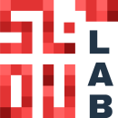](https://builtin.com/company/solulab)

**Location:**Los Angeles, California

* [SoluLab](https://www.solulab.com/) offers services to support companies with blockchain application development.
* For the healthcare industry in particular, SoluLab’s solutions can help to determine the authenticity of drugs and medical data by tracing their origin, as well as encrypting data.

### 14. FARMATRUST

[](https://builtin.com/company/farmatrust)

**Location:** London, England

* [FarmaTrust](https://www.farmatrust.com/)’s blockchain solutions have applications for tracking pharmaceuticals, determining the authenticity of medical devices, and maintaining data security for patients scheduling vaccinations and diagnostic testing.
* The company’s services help to keep [fake drugs](https://builtin.com/cybersecurity/while-youve-been-distracted-covid-19-counterfeit-drug-surge) out of the supply chain, for example, while also offering an app that lets consumers check whether medicines are genuine.

### 15. SHARECARE

[](https://builtin.com/company/sharecare)

**Location:**Atlanta, Georgia

* [Acquiring doc.ai](https://about.sharecare.com/press-releases/sharecare-completes-acquisition-of-doc-ai-enhancing-digital-health-offering-with-innovative-ai-solutions-and-tech-capabilities/) in 2021, [Sharecare](https://www.sharecare.com/" \t "_blank) has capitalized on its enhanced engineering expertise and developed a decentralized research platform.
* The [Smart Omix](https://www.smartomix.com/) platform makes it easy for researchers to prototype, revise and launch mobile studies.
* In addition to housing patient records, Smart Omix allows researchers to collect patient data via wearable devices and offers features like e-consent for a faster research process.

### 16. NEBULA GENOMICS

[](https://builtin.com/company/nebula-genomics)

**Location:** San Francisco, California

* [Nebula Genomics](https://nebula.org/whole-genome-sequencing-dna-test/) is using distributed ledger technology to eliminate unnecessary spending and middlemen in the genetic studying process.
* Pharmaceutical and [biotech](https://builtin.com/biotech) companies spend billions of dollars each year acquiring genetic data from third parties.
* Nebula Genomics is helping to build a giant genetic database and incentivize users to safely sell their encrypted genetic data.

### 17. ENCRYPGEN

[](https://builtin.com/company/encrypgen)

**Location:** New York, New York

* The [EncrypGen](https://encrypgen.com/" \t "_blank) Gene-Chain is a blockchain-backed platform that facilitates the searching, sharing, storage, buying and selling of genetic information.
* The company protects its users’ privacy by allowing only other members to purchase genetic information using safe, traceable DNA tokens.
* Member companies can use the genetic information to build upon their genetic knowledge and advance the industry.